June 11th, 2006
Hi Gavin
So, this is the first ‘post-op” letter! Lucky I am writing it on the computer rather as a regular letter as I am able to type using my fingers but it is very difficult to do handwriting due to the wound and dressing on my right wrist. I will write separate letters this week. (Actually, the letters are almost the same except that Nadine’s will contain a special ‘Happy Birthday” banner.) Actually a double celebration with Leonie finally getting her MD after all these years of hard work!

As I wasn’t able to write last week, there is two weeks to report on and because of the hospital visit, the letter should be longer than usual.
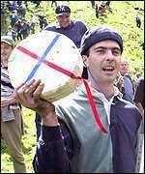
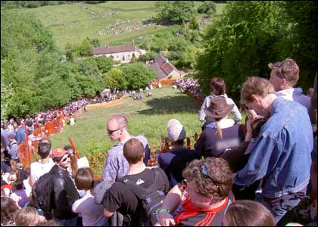
I will begin with an interesting item I saw on TV about the annual cheese rolling races in England. For each race, a large cheese is rolled 200 metres down a steep hill. The winner is the one who manages to get the cheese. It seems that the race may go right back to Roman times. The photographs show the general scene of last year’s races and one of the winners for this year. The busiest people on the day are probably the paramedics as many people suffer nasty falls.
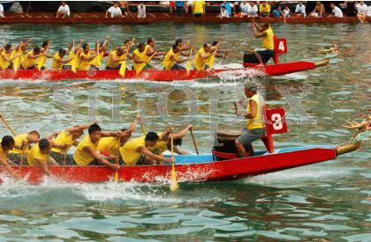
For the week before going into hospital I did swimming and weights but rested on the day before admission. I don’t know how long I will have to wait before getting back to it again.
Wednesday the 31st May was Dragon boat day public holiday with the races in various parts of HK. The international races were held on the following weekend.
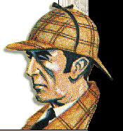
Remember I had ordered the Sherlock Holmes booklets from Stanford. Well, they arrived the day before entering hospital so I packed them just in case I needed something to read. Also took TIME magazine and language books. As I only stayed in hospital for two days and one night, there was not much time for reading.
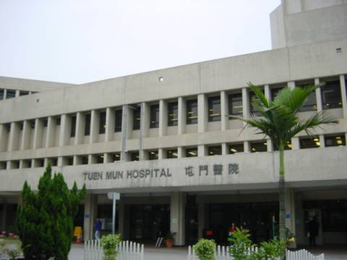
On Friday 2nd, I left for Tuen Mun hospital about 7:15am. Registered at the admissions desk, which opens at 8 am. After that, went up to the male surgery ward. Turned out to be not bad. The ward has a total of about 40 beds and I was in a section with just five beds. (Much different from when I was in a general ward at Queen Elisabeth Hospital (QEH) many years ago when the ward was a single large room. In addition, this time, the toilets were clean! During the QEH visit, the toilets were filthy!) In the morning, they got me ready for the operation. I was wheeled into the Operating Theatre at about 12:30. The operation began about 1 pm and lasted 1½ hours but I didn’t regain consciousness until 4 pm. Had dressings over the stitches on my face while my right wrist, left foot and upper thigh (where the skin for grafts on the hand and leg had been taken from) were heavily bandaged. To prevent my foot from moving to allow the graft to ‘take’, my lower left leg was in a brace. Had ‘dinner’ later, but the food was lousy. There was also an annoying guy in another bed who wanted TV on and loud! Slept OK, but wore airline eyeshades and earplugs I had packed which turned out to be useful as lights are not turned out until late and some lights are on all night. The next morning the breakfast was even worse than the dinner! In the afternoon, the doctor in charge said it was OK to go on ‘home leave.’ Collected a walker before leaving which was not much use anyway as I could only hold it with one hand. I was able to manage at home though it was difficult.
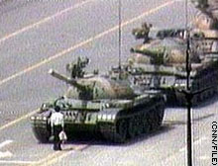
Last Sunday was the Anniversary of the June 4th 1989 massacre in Beijing. There was rally in HK with about 40 000 attending.
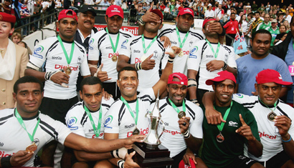
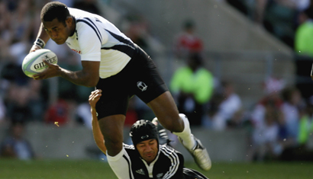
Sunday was also the final day for the final tournament of the World Rugby 7s series, held in London. Fiji won the tournament and the 7s crown; they beat NZ 21-17 in a semi-final with a last minute try. Therefore, this is the first year that NZ have not been the champions. They ended up only 4th this time, behind England and South Africa. Pictures show the Fiji squad after their victory and scoring in the semi-final against NZ.
Last Monday, I was back at work, and worked all day. A basket of fruit arrived in the afternoon from the leasing staff downstairs. They had seen me arrive back on the Saturday and were duly shocked at what they saw!
Did you hear about some people believing that last Tuesday was to be the end of the world? This was because the date was 6-6-2006 or 666! which is the number in the Book of Revelation in the Bible referring to the ‘beast; or the ‘antichrist.’ The number refers to the Roman Emperor Nero who was brutally suppressing Christians when the book was written and 666 is the number obtained when the letters of the Hebrew name for Nero are converted somehow into numbers and added up.
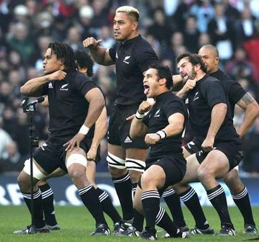
The southern hemisphere international Rugby season gets underway this weekend. The All Blacks play the first of two tests against Ireland in NZ. (Won the first, yesterday 34 – 23, but only after a struggle.) Australia play England and South Africa play Scotland. The All Blacks will perform the traditional ‘Ka Mate’ haka before the first Test against Ireland. They had been ‘persuaded’ by the NZ Rugby Football Union not to perform their new ‘Kapa’ haka, which the players like a lot. The ‘Kapa’, first performed against South Africa in Dunedin during last year's Tri-Nations, has a controversial ending as it finishes with the players drawing an imaginary knife across their throats in a throat-slitting gesture (as the photo shows). Because of the build-up to the Rugby World Cup next year, enough All Blacks have been selected for two teams. Therefore, a second team will be going to Argentina to play tests there.
Last Thursday, I returned to the hospital to have the facial stitches removed and all the other wounds dressed. Both skin grafts had ‘taken’ OK. Returned the walker. Went again yesterday to get new dressings. I am supposed to return daily for dressings but yesterday there was very heavy rain and flooding so I didn't go. Actually, I didn’t want to go as I wanted to finish the manuscripts for the revision of the Singapore science books, which I did. While these, found out I had actually been discharged last Thursday! This explained why someone else was in ‘my’ bed when I arrived. After the visit, paid the fees and charges for my hospitalisation, which totalled just HK$650, which is $50 for admission and $100 per night (had to pay for the nights of home leave). Everything else included. The receipt issued is interesting as it not only stated the sum of $650 received but also included the average amount of the government subsidy for cases similar to mine, which amounted to HK$21 000 and is about what I would have had to pay had I been a ‘non-eligible’ person, i.e. not holding a HK ID card.
Other news:
Cathay Pacific Airways has bought out DragonAir so it now gets access to China routes which it did not have (except one or two) whereas DragonAir has many. ‘Good’ news, I suppose, that Al Zarqawi has been killed in Iraq from a US air attack. Heard on the news that NZ has deported a Saudi Arabian who was there taking flying lessons. It turns out he was an associate with one of the highjackers who crashed the plane into the Pentagon.
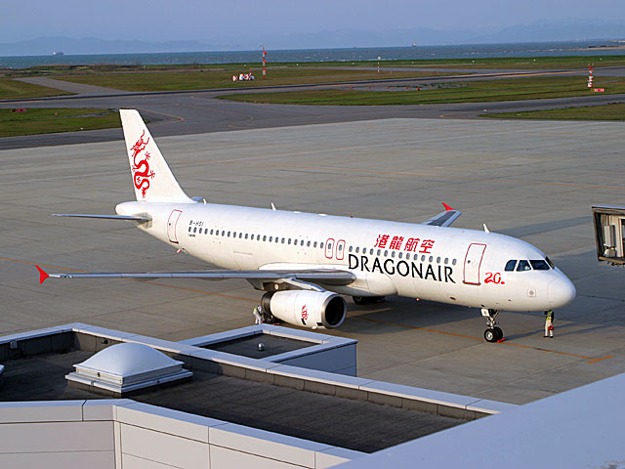
That seems to be it for now. Actually, it is quite a lot!

Cheers

